40 Years of CPE in Australia – Is there a Promised Land?
Mosaics and mystery: pastoral care, clinical supervision and
public health
Mary Klasen

Introduction

The title of today’s conference invites us to stop and reflect on 40 years of CPE in Australia. It encourages us to take heart and, with trust, to look to the future. That said, it also suggests some challenging notions. Is this the Promised Land? If it is, have the last 40 years been a desert experience? Or are we still searching for a Promised Land? Will we be like Moses and Aaron denied access to the riches of a destination where we have arrived and need to journey no longer? Perhaps, desert and Promised Land can co-exist. I like to think so. Indeed, I believe that the anticipation of a Promised Land can sustain us through the desert years. So, let’s look at the richly textured landscape of CPE in Australia, at the life that continues to flourish and at the new sources of refreshment. Does it flow with milk and honey?

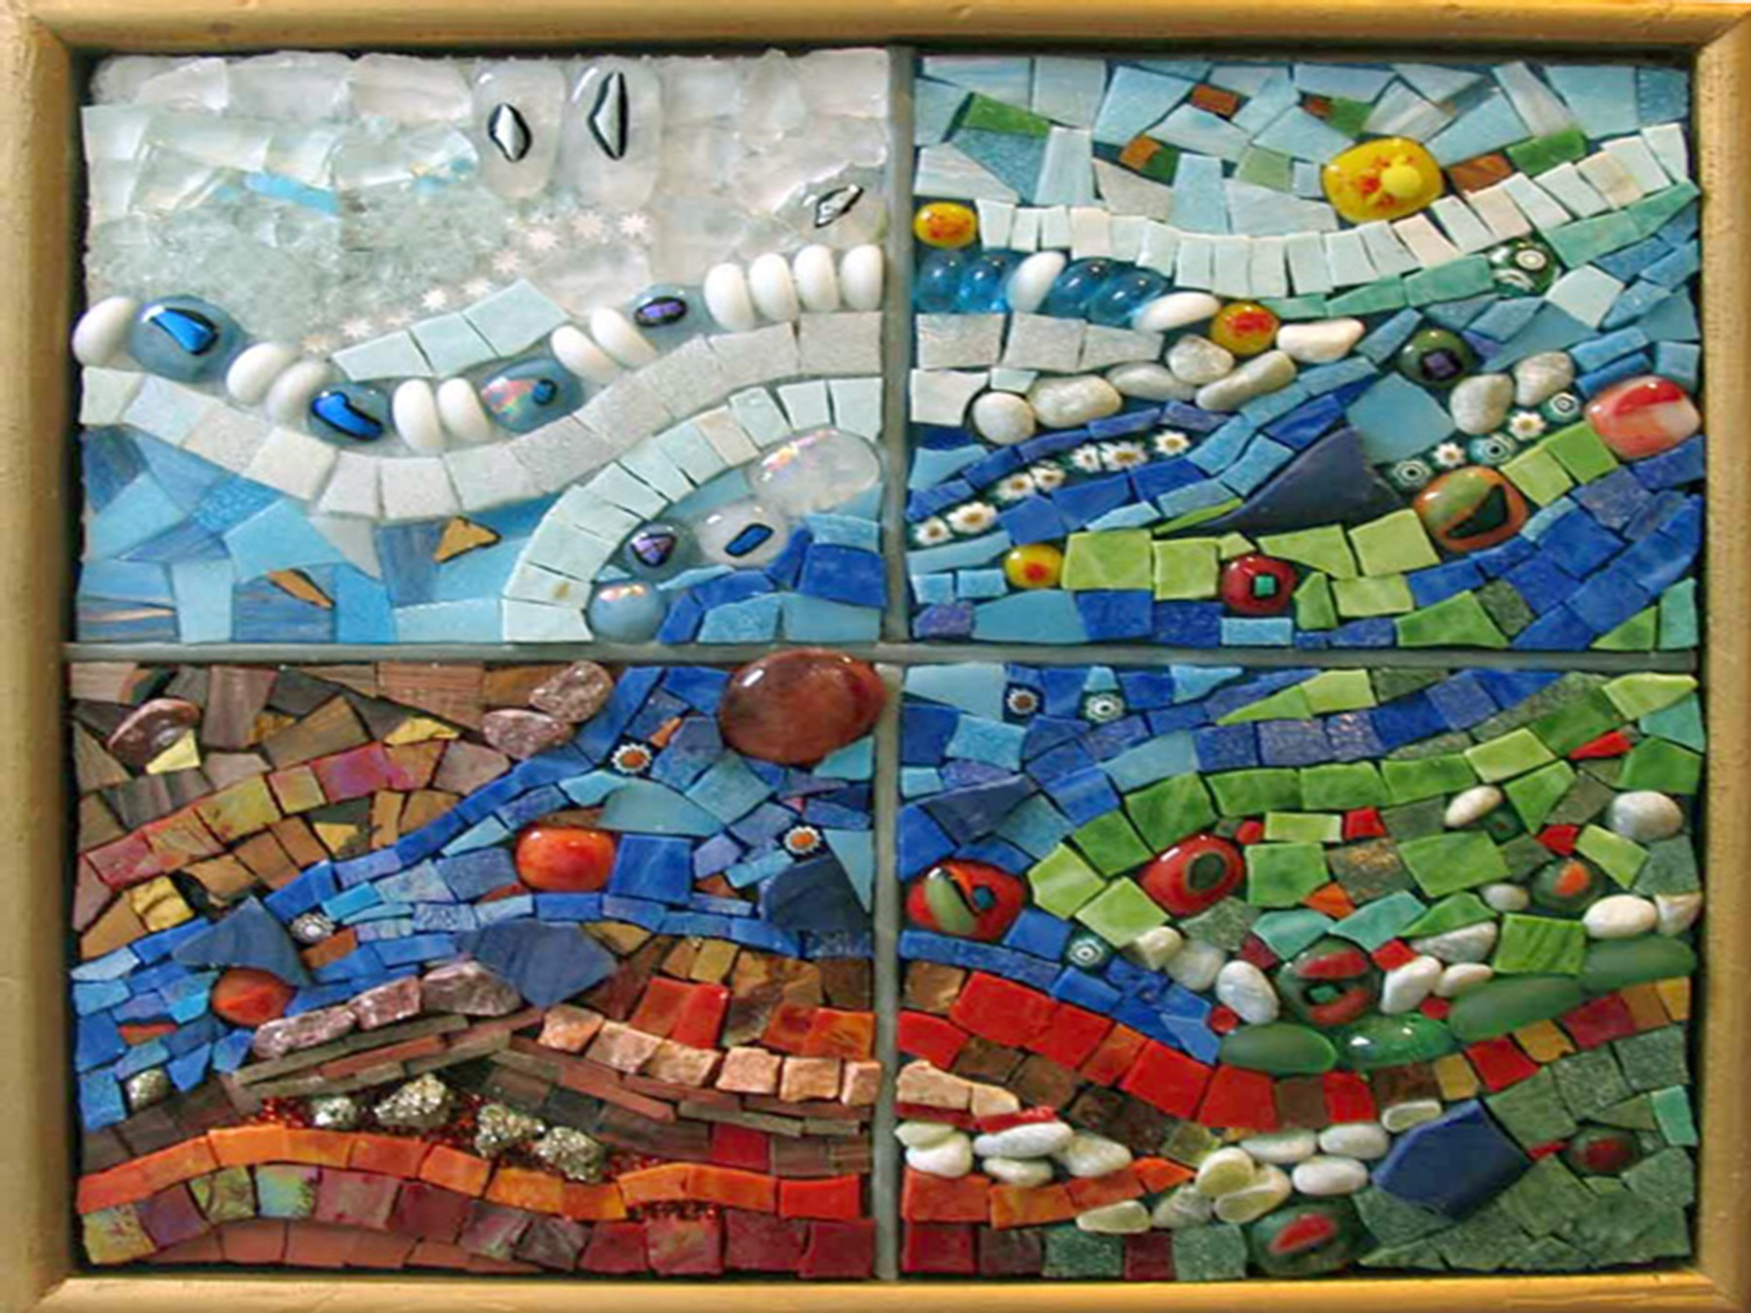

This presentation draws on my own experience and conversations I’ve shared with Roy Bradley, Julie O’Brien, David Dawes, Gillian Henderson and Dan Murphy; and the Pastoral Care team at Mercy. With the insights gained, I view the last 40 years, the ‘desert’, as a place of surprise, grace, and generativity – hardly barren! Indeed, both Roy and Julie in their narrative of CPE in Australia spoke passionately of the richness of the last 40 years.

At the AHWCA conference in March 2007, Roy presented an address titled, “40 years of CPE in Australia – Hardly a wilderness!” Roy’s address was marked by gracious recognition of God’s constant providence to him, both personally and professionally, in the establishment of CPE in Australia. He described how the enterprise flourished by the donations and endorsement obtained from within both the Christian churches and the medical profession. He claims that CPE launched him on a quest to find his place in the universe. He found his place and meaning for his life, therein enhancing his autonomy and authenticity. CPE opened up a promised land for him as an individual. Roy acknowledged that CPE was not the sole catalyst for this growth – psychotherapy also played a significant role. He has inspired me to offer pastoral care and supervision that recognises and facilitates the autonomy and authenticity of others.

Julie’s immediate response was that the last 40 years of CPE held for her the richness of the Promised Land. Later she wondered if CPE does not always sit on the margins – never the fertile land. She believes that the educative process enables human flourishing. So often she has witnessed the birth of new life for herself and others. In her experience, participants’ lives can be transformed when the reflective capacity becomes innate. As we know, in practising the art of pastoral care, people are able to assist another in making sense of what is happening in their lives. Pastoral care provides the space to unfold what lies beneath the reaction, the response, or lack of response.

This capacity to provide such space is strengthened through spiritual and theological reflection. These aspects of pastoral care lead Julie to ponder –‘What promise do we give to them?’ and ‘Can they live with what is opened up to them?’ (‘Them’ refers to those receiving pastoral care and CPE participants.) These are important questions in our professional practice of pastoral care and supervision. We cannot offer empty promises. We need to take appropriate responsibility for where another might go in their opening up with us. I believe that in our considerations of CPE for this time, these questions need to be recognised and explored.

Locating myself

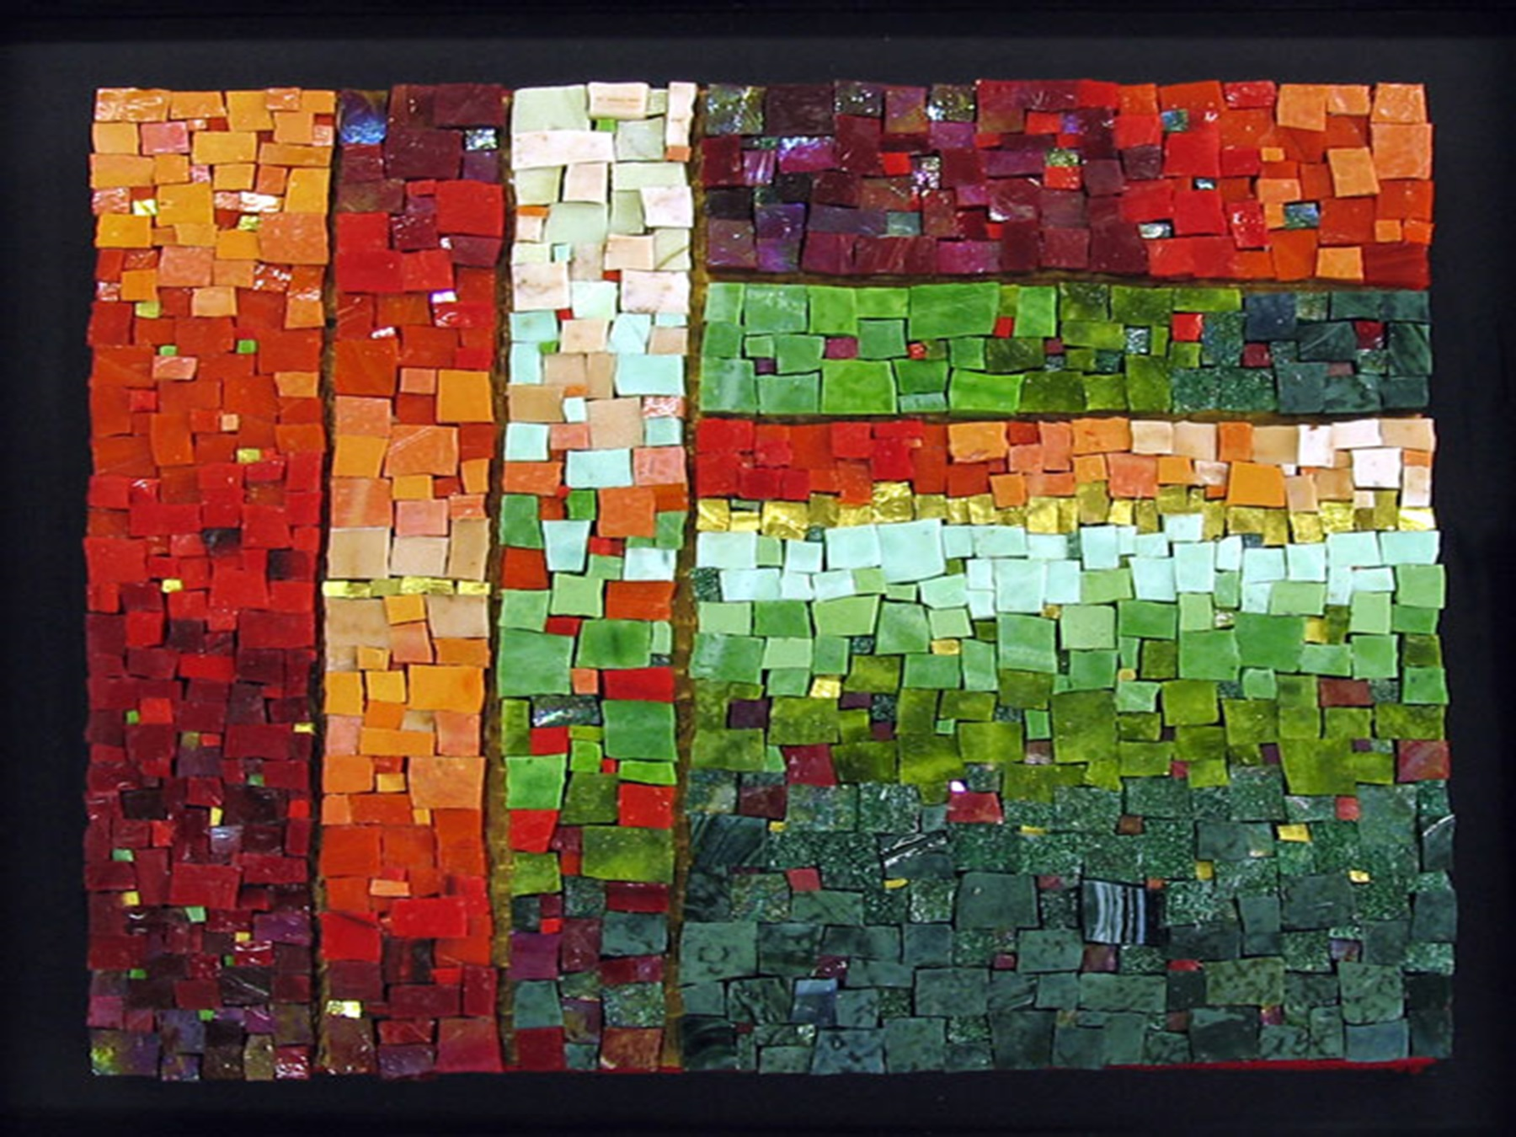

There has been many a time over these last months when I’ve wondered why on earth have I been asked to give this presentation … In my more generous moments, I acknowledge the uniqueness of my CPE, pastoral care and supervisory journey. I came to CPE at Peter MacCallum Cancer Centre out of a profound sense of calling. To my deep delight, I found I was at home in being the pastoral carer for the haematology ward. I was invited in to be an integral part of the multidisciplinary team. In recognising and valuing the contribution of the other team members, the value of pastoral care was also honoured. CPE enabled me to build my personal and pastoral identity and capacity within this public health setting. In this development, I discovered further dimensions of my truth and came ‘home’.

As many of you know, I was subsequently blessed with the creation of a pastoral care position on this same ward. To be invited back by the staff was sure confirmation of my initial risk to step out into pastoral care. Two years later David Dawes was successful in negotiating with PeterMac management a permanent, full time pastoral care position. In this security and affirmation, I savoured the delights of a Promised Land!

Two years later, I was encouraged to take the next step into supervisory training. I was fortunate to be in a department that supported and enabled this movement for me to become a clinical supervisor in December 2005. I began this journey by first rediscovering the joys and challenges of doing a CPE Unit. I joined the group as a learner and as a staff member. This holding of different roles in the same context has continued. Throughout my practice of supervision I continued my clinical practice of pastoral care. For me, this first hand experience informs, enlivens and challenges my supervisory practice. Now my clinical practice brings energy to the constant administrative and management responsibilities.

Much to my surprise, I now find myself at Mercy Hospital for Women. I’m surprised for I relished the challenge of working in a public hospital and the freedom this gave. Whilst still being a public hospital, I had not envisaged that I would again choose to work in a Catholic setting. I feel called to own my strong catholic heritage, to do this in a place that honours its origins, whilst offering professional pastoral care to all patients and their families. I am honoured to be asked to build on the strong CPE foundations that have been laid with the Mercy CPE Centre.

Mosaics and mystery

I have called my reflection today, “Mosaics and Mystery”. How have I arrived at this? Mosaics construct and relay a story, an experience, or an insight. They are works of art. Traditionally, mosaics are individual pieces of materials placed together to create a unified whole. The spaces between the fragments of shapes are filled with grouting. While mosaics are factual or metaphysical creations, they are also mystery because their inspiration, and/or meaning often arise from a source that we cannot name.
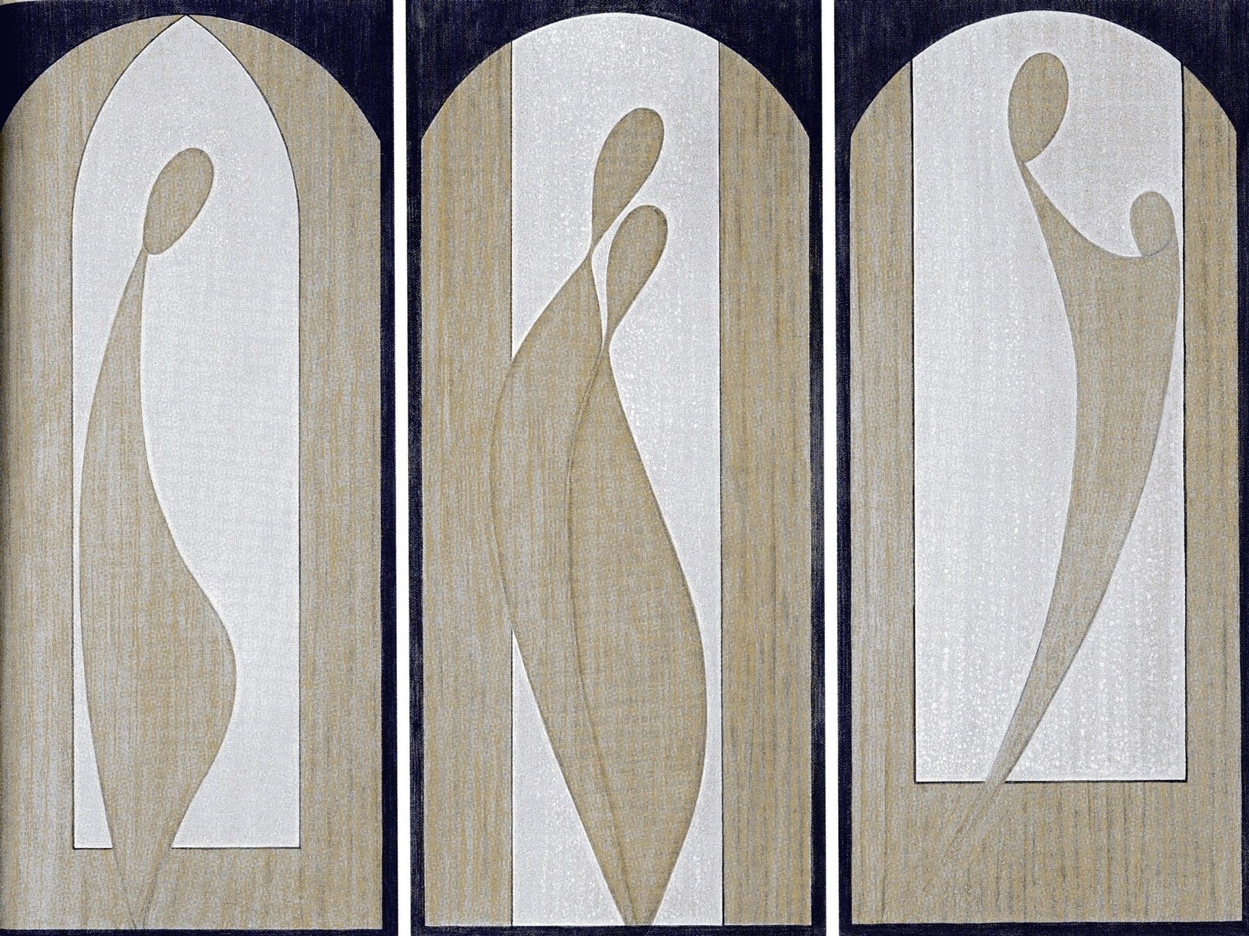

It is often a mystery how the shapes, textures and colours come together, and what is named and unnamed. However, often the fragments of my or others’ experiences do not come together in any apparent pattern or mosaic. At these times, it is only mystery that embraces me. On occasions when I experience life and death being inextricably linked, I sit with mystery trusting that one day a mosaic will emerge, for those involved and for me.

One of the key texts underpinning my work in pastoral care, as in life, is the Magnificat. (Luke 6:20-24) ‘My soul proclaims the greatness of God and my spirit rejoices’... According to Luke’s gospel, Mary visited her cousin Elizabeth who had become pregnant after many barren years. The Magnificat is the name commonly given to Mary’s Song of Praise in response to Elizabeth’s warm, loving welcome. Various biblical scholars’ consider that the Magnificat was not a spontaneously composed prayer in this moment of welcome. Rather, they believe that Luke crafted together a mosaic of phrases from the Hebrew Scriptures that Mary could have prayed. This mosaic of phrases is repeated in Luke’s beatitudes. The glue that holds together the coloured fragments of my life, forming a mosaic, is my own Magnificat, inspired by Mary’s and Hannah’s songs of praise at God’s unexpected and unfathomable goodness.

Mary’s Magnificat is most profoundly a journey. She sings of God’s life transforming acts in her life and reminds us of God’s mercy and faithfulness that enables justice for all. Mercy has been suggested as the key concept within this song of reversals, since mercy reveals the compassionate presence of God toward those – both ancient and contemporary – who suffer. God’s mercy is a free gift, unmerited and unending from generation to generation. It is this understanding and experience of God that gives me the courage to risk engaging with the young couple who await the death of their new born baby, their beautiful baby, when the promise of new life is shattered in the very act of giving birth. I am enabled to remain present to this most unfathomable mystery. In doing so, they speak of their grief and equate it to the ocean. They love the ocean. When surfing, they experience the heights and the depths, the power and strength of this rhythmic movement that lifts and throws them. They begin to find the fragments, the start of a new mosaic being crafted at a time of profound grief, confusion, and disbelief. They begin to find expression for their spirituality.

The placement of Mary’s song of praise in response to Elizabeth’s joyful recognition of Mary’s pregnancy reminds me that my experience of God, my understanding of truth and justice, arises in relationship, in companionship with another. Recently, my encounter with Michelle reminded me of the importance of language. Her second child was born unresponsive without a known reason. Medical and nursing staff kept telling her that they did not know ‘what was wrong with her son’. She found this statement grating – her baby was gift to her and her husband – not a problem to be solved. She loved him and was sad that family and friends had not acknowledged or celebrated his birth. I learnt again from Michelle the danger of focusing on the apparent ‘gaps’, on what seems to be ‘wrong’, when there exists a bigger picture.

My pastoral practice and supervision experiences generate precious fragments some of which I craft together whilst others remain un-crafted. The mystery is what they reveal in those moments when I sit in reflection or quiet contemplation.

Mosaics of Pastoral Care practice in public health



I’d like to share some of the fragments of my experience as a pastoral carer within the public health system and what informs this practice. Some experiences seem like deserts and others like a promised land.
On occasions, practicing pastoral care in the public health system can feel somewhat dry and arid; I can feel parched and lost. These are the occasions when patients do not have access to pastoral care because hospital personnel are uncomfortable with the spiritual domain, or determine that they can provide spiritual care for a patient and his/her family. It can be a challenge to articulate what pastoral and spiritual care mean and involve. The pragmatics of limited funding can make the provision of pastoral care difficult to resource. Sometimes it seems like we must practice in a context that either does not understand or cannot support the pastoral and spiritual needs of patients and families. So often, spirituality is understood only as religious practices and affiliation with mainstream churches. It is hard when the perspectives of different professions within the hospital system seem to compete for the opportunity to attend to patients and their families.

Then there are occasions when the milk and honey flow. At these times, the patient and his/her family are the centre of professional attention and the pastoral, spiritual, and other needs are recognised, respected, and held. To be a respected member of a multidisciplinary team allows for the provision of holistic care. This has been most possible when I have been able to stand in my authority and authenticity as a pastoral carer. What I really treasure are the times when we as a pastoral care team have been able to provide meaningful rituals for patients, families, and staff. At a recent staff awards ceremony, I took a risk and offered a different ritual that sought to honour our spiritual diversity. Three people were invited to tell their story of working at Mercy. The voices were those of a doctor, a cleaner, and a nurse. A real sense of celebration and community was generated by the story-telling. I sense a Promised Land when I witness the honesty with which a patient and his/her family share what is most profound or precious. It is the moments of rawness when I am trusted implicitly - when the layers are gone and the truth is exposed or revealed. In these times of sacredness, mystery surrounds and holds us.

‘Tony’s’ Story: Just before their early delivery, Tony and his partner ‘Lisa’, were informed that one of their twins had died. Both were shocked and rattled by her death whilst holding joyfully her sister. When exploring possible options for the care of the deceased baby, Tony could not fathom how you could have a funeral service – it would not be possible to have a eulogy – there would be nothing to say. I offered that if could be an honouring of the time that she has been a part of their lives and all that she has come to mean to them, their hopes and dreams for her and a ritual to say ‘goodbye’. As they asked to view their daughter two days later, I offered them the book – ‘Guess How Much I Love You’ as a story to share with their daughter. The following day, Tony again requested to see his daughter, which he did alone as his partner had said her ‘goodbyes’. When I returned sometime later, he wept quietly and shared with me how he had told her how much he loved her, what she would always mean to him and gave thanks for her. I was moved so deeply – he had created his own, most profound ‘funeral service’.

In my practice of pastoral care, I find most challenging what I have come to see as the tyranny of being positive. How many times have I heard, “I’ve got to stay positive!”, “I can’t let myself cry”, “I’m coping”, or “You’ve got to fight it”. The Christian imperative to trust in God can be replaced by an often harsh imperative of being positive. No space for natural human fears, doubts or sadness; a stifling of the possibility for the integration of all aspects of life. I can acknowledge how important and powerful our thinking can be in relation to our well being. Yet where is the place for respectful self awareness, wonder, questions, and mystery?

A further challenge is the danger of relying too much on the “shared experience” to inform my understanding of another’s experience. I know that identifying too closely with the other can limit my ability to really understand the uniqueness of what is happening for the other and, therefore, what meaning the other person might construct. I have learned to respect the importance of our “differences” because it is in these differences that unimpeded space is created for their meaning to emerge. I work in a maternity hospital but I have not had children. Some would think, if not say, what do I know about birth and babies and breastfeeding? (One new mother recently mistook me for the “boob lady”.) My life’s journey creates a significant point of departure from the experience of many people to whom I offer pastoral care at Mercy. Does this being on the edge enable me to listen, without assumptions, without the points of connection? At times I grieve these points of departure. Yet, I believe it helps me to listen more intently, to explore more creatively, and to facilitate more other-centred mosaics and rituals.

Over the past 40 years, our understanding of pastoral care practice has, of necessity, evolved in response to the needs of an ever-changing world. At a recent conference on ‘Spirituality and Healing’, Maryanne Confoy, in relation to the question ‘Who am I?’ posed another question: Is the life I’m living the same as the life that wants to live in me? Am I true to myself? This quest is the spiritual journey for each of us, necessary if we are to be authentic, integrated and at home with ourselves. The key ingredients of spirituality that are integral to the search for meaning and purpose for life, according to Confoy include the following:
- conscious effort to increase awareness;
- integration of all aspects of life;
- self transcendence that is beyond self sacrifice, self-absorption and self-fulfilment;
- and reaching towards the Ultimate, whatever that might mean for the person.
As a pastoral carer, I know I need to give space and time to the nourishment of my spirituality, mindful of these key ingredients. This schema can also provide a guide for spiritual assessment, in turn, informing my pastoral practice.

Mosaics: clinical supervision in public health

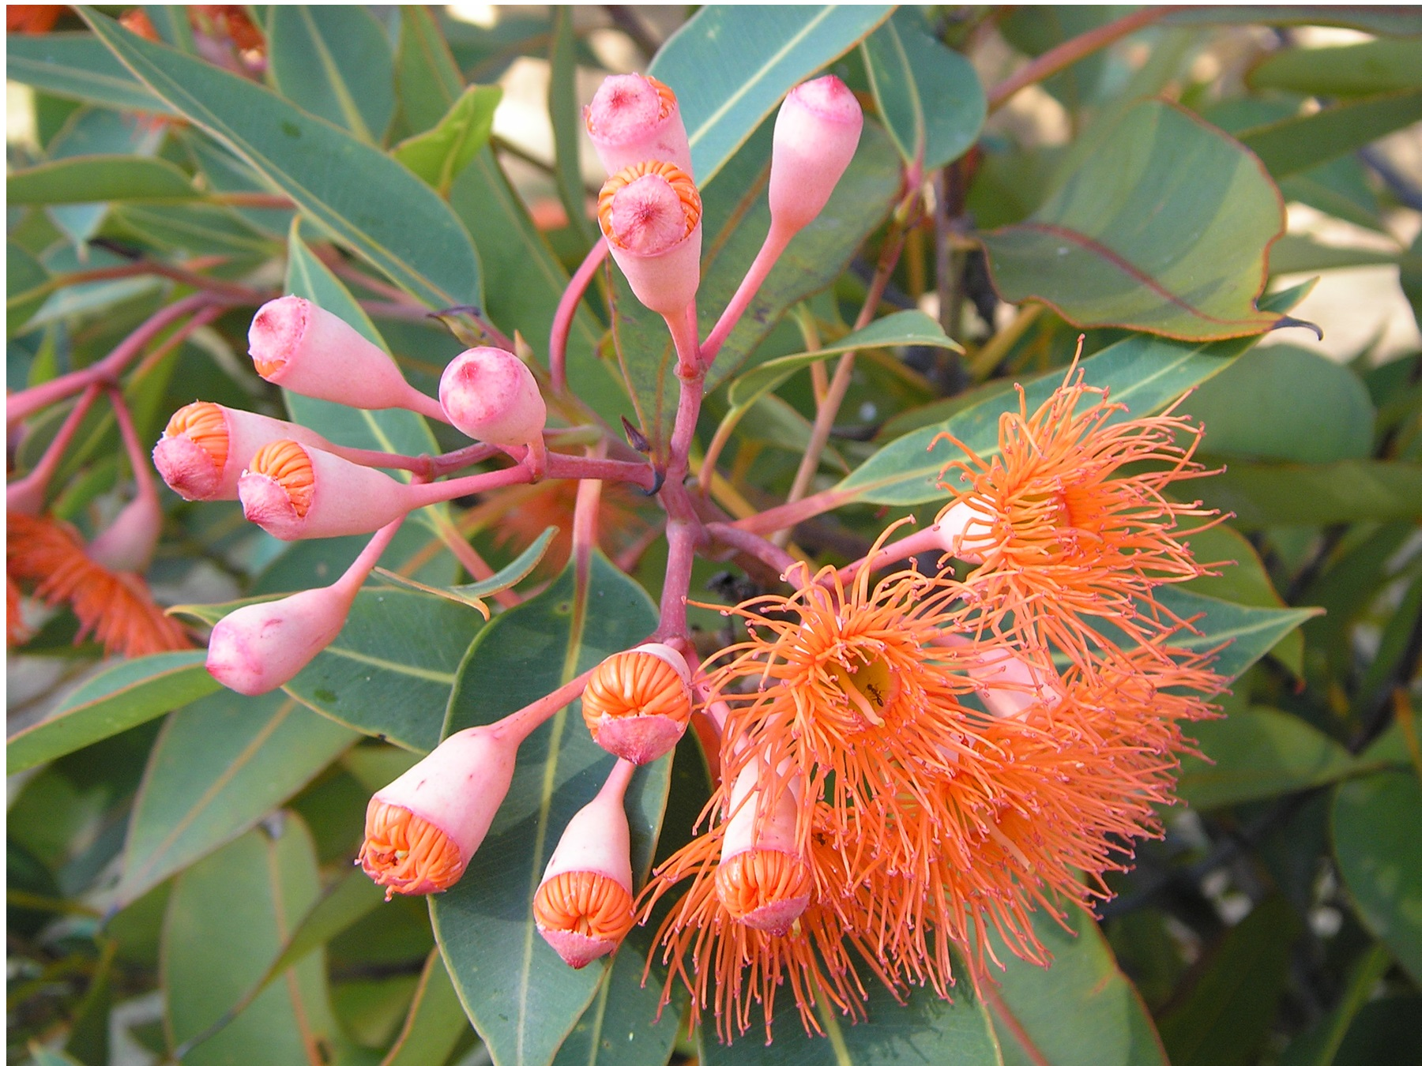

There are also the fragments of my experience as a clinical supervisor within the public health system.

Geoffrey Robinson’s recent book, ‘Confronting Power and Sex in the Catholic Church –reclaiming the spirit of Jesus”, in its profound clarity and honesty, brought new life to my spirit. In 1994, Robinson was officially appointed to lead the committee responsible for investigating abuse within the Catholic Church. In his book, he describes how he moved through three stages whilst in this role. Firstly, he came wanting to work out of being a good human being, a good Christian, a good priest. Secondly, he sought to listen to as many victims as possible in order to learn from them. Finally, in this listening, he found that what others were saying stirred strong echoes within his heart and mind. This led him to attend deeply and honestly to his own experience of abuse. In having attended to and honoured his own reality, he sought justice for others. In doing so, he challenged the Catholic Church to respond with strong and compassionate leadership to the victims of abuse within the church.

Robinson’s experience resonates with what I believe is the experience of CPE participants training to be pastoral carers. Many come to CPE training because they want to be a good human being, to be a good Christian, and to hear the other’s story. The process of spiritual and theological reflection requires that they honour the stirrings, the echoes in their hearts and minds. I challenge them to be in touch with their own spirituality and to name how these experiences have changed or transformed them as human beings. Such enhanced self-awareness can clear the way and create space for strong and compassionate listening. The CPE process needs to encourage integration of participants’ experience whilst exploring how this shapes the uniqueness of their pastoral stance. At times a focus on attending and listening needs to be held to strengthen participants’ capacity to engage competently with another. An understanding of the context, relevant issues, rituals, loss and grief, faith and spiritual expression I consider to be important curriculum considerations for building a professional pastoral identity.

In my current context, the question stirs for me: how can CPE remain faithful to the spirit of Boisen in training people to provide spiritual care in public health? In the tradition of Boisen, spiritual formation of pastoral carers is possible when issues of meaning and life’s purpose are considered in ‘the context of a relationship with a living person and in whose companionship’ we seek the appropriate response. In the practice of spiritual care within public health we can continue Boisen’s motivation for supervised clinical residency “to better understand the deeper forces in humans that contribute to their illness and health”. In this understanding there is an important role for pastoral carers to contribute to the holistic care of people and for clinical supervisors to ensure the generativity of the profession.

As a supervisor I also heard in Michelle’s story the danger of focusing in on what is wrong. In my striving for professional pastoral care, I can struggle to let go of what seems to be wrong and to simply celebrate what is – one of my greatest challenges in supervision. Yet for many participants this genuine acknowledgement of what is, encourages them to become more effective pastoral carers. Ann in a final evaluation commented, that while ever I was her supervisor, she would never be complacent. I trust that this was creative for her. Being professional does not allow us to be complacent for the context is forever changing and each individual is unique. Also, we need to develop clear language around what we do; otherwise we will primarily be associated with dis-ease, death or religious practices.

At Mercy I am continually challenged by this tenuous holding of life and death within the same context. Exploring the challenge of attending to such significant grief, so often unnamed or recognised, in the midst of new life calls for attentive listening, secure grounding and surrender to the mystery. This new challenge informs and shapes my preparation of CPE at Mercy.

Mystery

It is mystery that stimulates, enlivens, shapes, and blesses the mosaic formation. My theological understanding and respect for life is significantly informed by Michael Whelan’s approach to the spirituality of human formation.
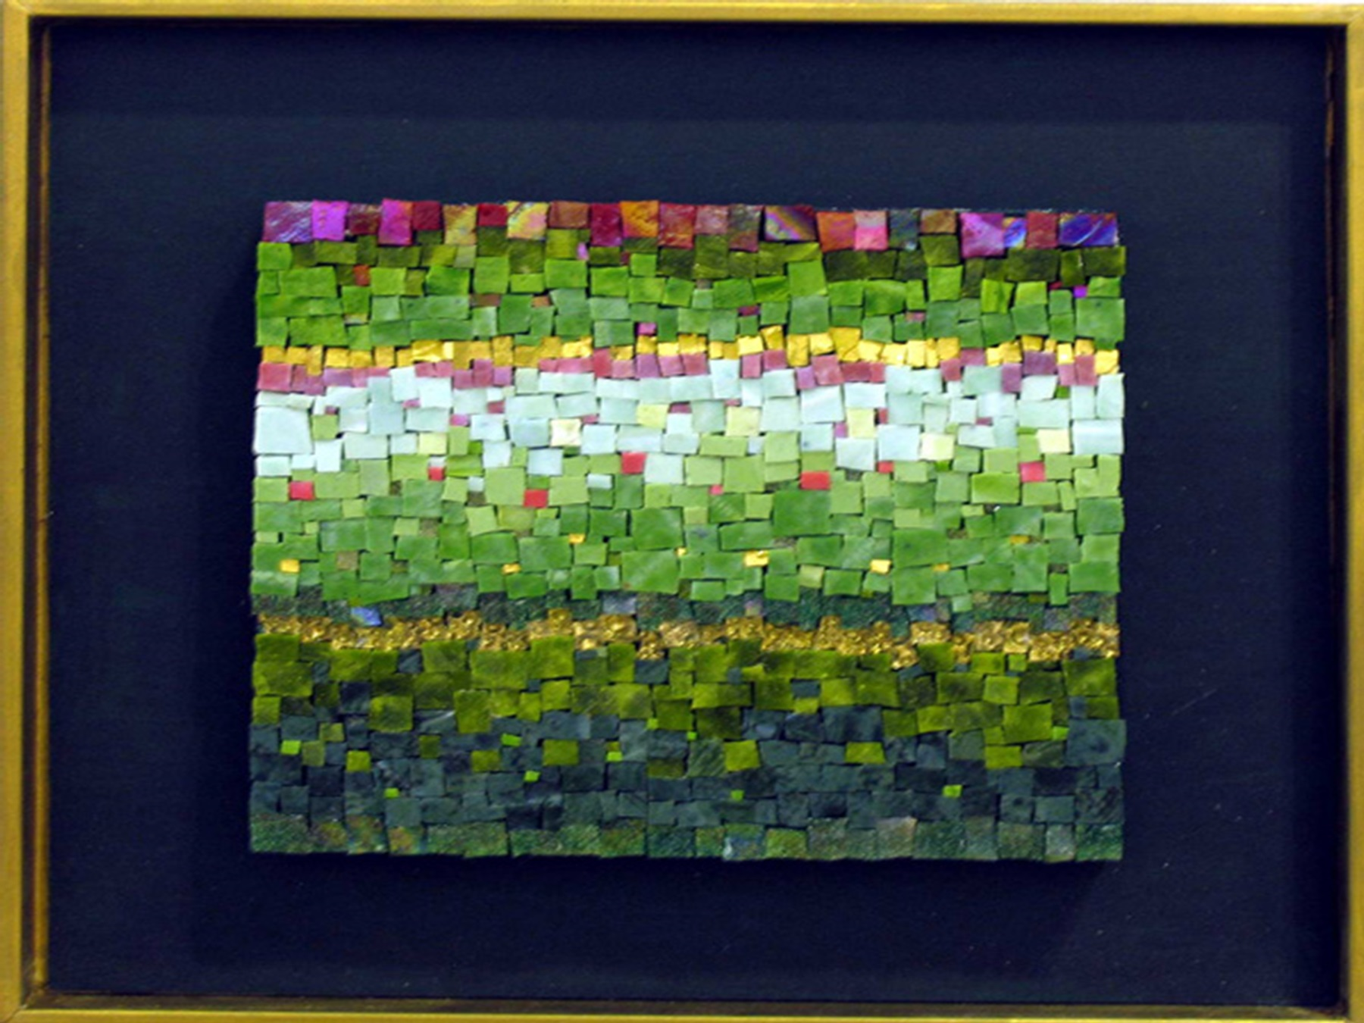

Whelan reminds us
‘In the end, life is not a problem to be solved. There is no solution to life. Rather, life is a mystery to be lived. (And by mystery we mean ‘inexhaustible intelligibility.) Life is not about mastery in the end but submission, it is not about imposing oneself on the world, it is about participation in the world. The human self is not a fabrication of wilful conquests or will-less passivity before the world, it is rather about conversation and facilitation. The self emerges as gift.’
What a fabulous roles we have as pastoral carers and clinical supervisors. We invite another into conversation, enable facilitation towards meaning, and hope that the other builds a stronger sense of self! This for me is the art of pastoral care and clinical supervision. In this engagement I too am transformed.

Like Mary and Hannah, I too have grown in my belief of God’s mercy and concern for the poor and lowly. God’s mercy enfolds three dimensions of God’s love – faithful, responsive and tender. I can dare to believe that I too am blessed and can be a source of blessing for others.

Story of blessing Janine’s twins and her belief in the work of God through me.
Janine has been a significant teacher for me as I grow in being a pastoral carer at Mercy. Her twins were born prematurely on my first day at Mercy. Two days later, I met her before a lecture. In conversation she told me that she also had a two year old daughter. I commented: ‘Wow, you indeed have your hands full.’ She responded immediately: ‘That’s the whole problem; I can’t hold them in my hands!’ Janine continued to teach me what it meant for her to have her babies for months in the Neonatal Intensive Care Unit. One twin was able to go home but the other remained in the unit, not growing in strength. After another serious setback, Janine approached me and asked if I would bless her babies in the unit. She had watched me doing so with others but wanted to wait for their baptism in the church. I created a ritual that honoured both girls, whilst also praying for healing strength. Within a fortnight, the second twin was able to go home. On leaving, Janine thanked me and said quietly, ‘she never looked back after the day you did that blessing of the girls. Thank you.’ Perhaps I too can dare believe that I can be a source of blessing for others.

Is there a promised land?

Stepping out in order to bring training for the practice of chaplaincy and pastoral care to different places does not mean that you can step onto solid ground. More likely the ground shifts like the desert sands. So today I honour those who have paved the way and who continue to be involved in the practice of CPE. I wonder if the analogy of the desert is accurate in so far as there were no clear sign posts for you to follow. Although there were some similarities between the social and religious contexts of Australia and the U.S., there remain significant differences. As Abraham and Moses stepped out in faith, so too have all those who have contributed to the development of CPE centres and the offering of CPE training in places with no centres.

There exist significant similarities between our present social and religious context and those of the 1960s. The shifts in society meant that the authority and traditions of the Christian churches was questioned and there was a move away from regular church attendance. In Hillard’s assessment, the late 1960s saw a new cultural style emerge, one ‘based on individual self-exploration, informality, spontaneity and immediate experience.’ This trend has resurged in this decade with the significant uptake of New Age philosophies and self help books in an unstable economic climate.

What is understood by a Promised Land in today’s context? Is it simply, yet most profoundly, that all people are given appropriate and holistic care? For pastoral care within public health, does it mean an environment where pastoral care can stand equally with our colleagues in allied health? Can we receive appropriate recognition for our role in supportive care to patients and their families? Does it mean that spiritual care is an important dimension of the care for all patients, not just those who are grieving, shocked, in pain, or bewildered? Could the diverse, ancient practices of meditation, yoga, reflexology, or tai chi be a part of the comprehensive care for patients?

What would it take to make this dream possible? In my questions and dreams, I am challenged to be a part of the response that will bring about this justice and a new way of being in the world. With my colleagues in pastoral care and supervision, within my workplace and within ASPEA, we need to uphold this vision of the Promised Land beyond this current rationalistic reality. We need to make a road where no road has been made before.
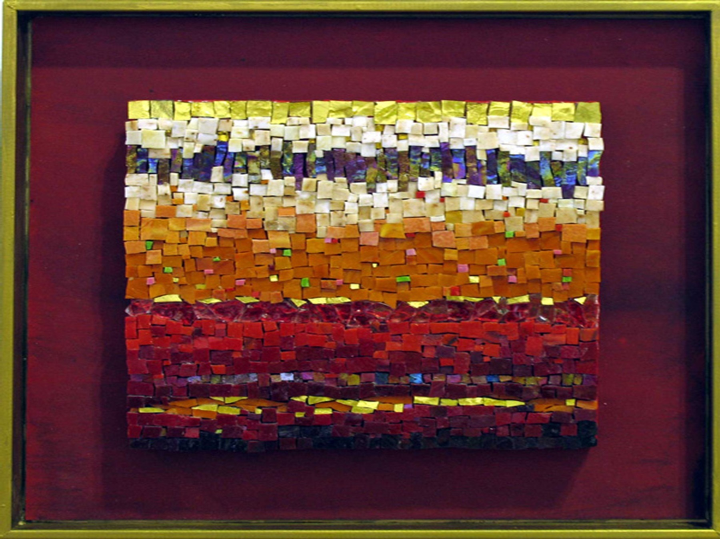

We’ve come today to celebrate 40 years of CPE in Australia whilst posing the question: Is there a Promised Land? We celebrate the great blossoming of CPE life in the Australian wilderness. Yet do we also question for we find ourselves in a place that is different from what was first envisioned for CPE. There is movement demanded from outside CPE training and from within, for stronger links with tertiary institutes and reflective process that acknowledges the diverse spiritual, religious and cultural world in which we live. There is a hunger for something more than the original CPE process whilst still maintaining its particular educational thrust and process of action/reflection. What is the role of ASPEA in these searchings? Are we able as an organisation to be clear about our mission and values? I believe that as an organisation our identity and purpose needs to be clarified to enter competently into discussions with tertiary institutes and health care settings.

Together, today, in this place, we form a CPE mosaic – one that has history and one that holds promise. Mystery is in abundance.
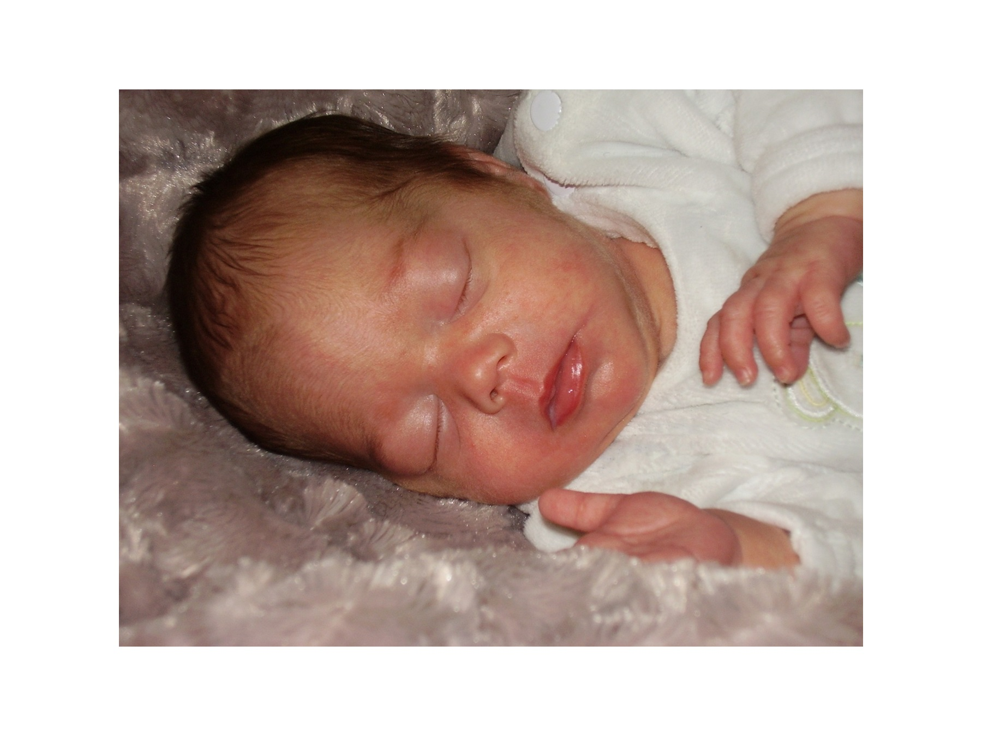
Conclusion

To conclude, if there is one core curriculum resource that should be used in every CPE programme, I would declare that it must be a viewing of the Movie ‘As it is in heaven’ with in-depth theological and spiritual reflection!! For me, one of the greatest joys in being a supervisory is to observe and encourage a participant to find their voice and to sing with others. Gabriella’s Song celebrates her facing the shamed aspects of her life and reclaiming her authority and authenticity. It has become for me a fresh version of the Magnificat.

Gabriella’s Song – As It Is In Heaven
Py Bäckman
Helen Sjöholm
It is now that my life is mine
I’ve got this short time on earth
And my longing has brought me here
All I lacked and all I gained
And yet it’s the way that I chose
My trust was far beyond words
That has shown me a little bit
Of the heaven I’ve never found
I want to feel I’m alive
All my living days
I will live as I desire
I want to feel I’m alive
Knowing I was good enough
I have never lost who I was
I have only left it sleeping
Maybe I never had a choice
Just the will to stay alive
All I want is to be happy
Being who I am
To be strong and to be free
To see day arise from night
I am here and my life is only mine
And the heaven I thought was there
I’ll discover it there somewhere
I want to feel that I’ve lived my life!

Shapiro Marion. Four Seasons Used with permission: http://www.dariandesign.com.au/mosaic/about the artist.htm
Shapiro, M Embers
Manning, J. (2005) Sacred Spaces Divinity of Love Image on Maternity Ward at Mercy Hospital for Women. Used with permission.
All stories about pastoral care practice are used with the permission of the participants.
Adamson, Irene (2008). Heidelberg gum leaves Used with permission
Confoy, M (2007) Presentation: The Journey of the dark night. Sources of hope in depression and darkness. At St Vincent’s Health Spirituality and Healing Conference October 2007
Robinson, G.(2007); Confronting Power and Sex in the Catholic Church, John Garratt Publishing, Australia
Whelan, M.; (2007) Self Awareness and Detachment from http://www.aquinasacademy.com/PDF/WEB%2016%20SELFAWARENESS%20AND%20DETACHMENT.pdf
Kenny, J. (2003) Finger Pointing to the Moon p.9
Marian Shapiro
Accessed from http://au.answers.yahoo.com/answers2/frontend.php/question?qid=20080219015948AAkxHYx; 20 February 2008.

